**College of Professional Studies**

**Northeastern University San Jose**

**MPS Analytics**

**Course: ITC 6000 - Database Management Systems**

**Assignment:**

**Module 3 Assignment SQL Murder Mystery**

**Submitted to:**  **Submitted by:**

Professor: VENKATA DUVVURI NIKSHITA RANGANATHAN

The programming language SQL (Structured Query Language) is intended for managing data stored in a relational database management system (RDBMS). It is used for adding, modifying, deleting, and retrieving data from databases. Common uses for SQL include creating new databases and tables, inserting, updating, and deleting data, and querying data from existing databases.

SQL functions are used to perform specific operations on data stored in a database.

* Understanding the data

Data can be chosen from a database using the **SELECT** query. This SQL command is used most frequently.

The tables from which data is fetched are specified using the **FROM** clause in a SQL query.

To figure out how many rows in a given table meet a specific requirement, we use the **COUNT** function.

All columns or all rows are represented by the wildcard character **\*** (asterisk).



**Output**



**Output**



**Output**

* Aggregation functions

The SQL function **AVG**, which stands for Average, is used to determine the average of a set of data. **MAX** and **MIN** are aggregate functions in SQL that return the maximum and minimum values of a given column



**Output**



**Output**



**Output**

* In SQL, the **LIMIT** clause is used to limit the number of rows that can be returned by a query. The **DISTINCT** keyword is used in a SELECT statement to tell the database to return only unique values in the result set.
* **Graphical user interface

  Description automatically generated**

**Output**

* 

**Output**

* Filter results

**WHERE** is a clause in SQL that is used to specify a condition while retrieving data from a database.



**Output**

* 

**Output**

* Text

  Description automatically generated with medium confidence

**Output**

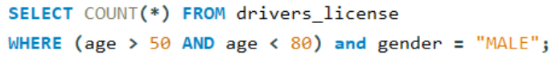

**Output**

**Output**

* **BETWEEN** is a logical operator in the SQL programming language that allows you to determine whether a value is within a certain range. To search for a specific pattern within a column, we use the **LIKE** operator.
* Text

  Description automatically generated

**Output**

* 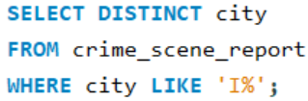

**Output**

* **ORDER BY** is used to guarantee a consistent ordering of results and can be used to sort by multiple columns.



**Output**

* Graphical user interface, text

  Description automatically generated

**Output**

* **GROUP BY** is generally used in a SELECT statement to organize similar data into groups.
  + Text

    Description automatically generated

**Output**

* A JOIN clause is used to merge rows of multiple tables based on a common column.
  + Text

    Description automatically generated

**Output**

* Text

  Description automatically generated

**Output**

* Graphical user interface, text, application

  Description automatically generated

**Output**

* Graphical user interface, text

  Description automatically generated

**Output**

* **SQL Murder Mystery**
* Text

  Description automatically generated with medium confidence

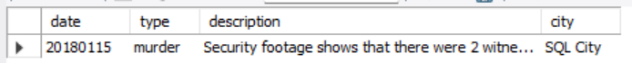**Output**

**Witness #1**

* Text

  Description automatically generated

**Output**

**Witness #2**



**Output**

Access the Witness Statements

* 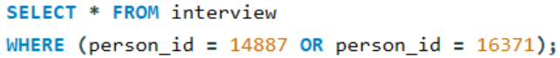

**Output**

* Text

  Description automatically generated with medium confidence

**Output**

* Graphical user interface, text

  Description automatically generated

**Output**

* Text

  Description automatically generated

**Output**

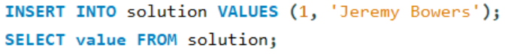

**Output** Congrats, you found the murderer! But wait, there's more... If you think you're up for a challenge, try querying the interview transcript of the murderer to find the real villain behind this crime.

* **Real Villain**
* A screenshot of a computer

  Description automatically generated with medium confidence

**Output**

* Table

  Description automatically generated

**Output**

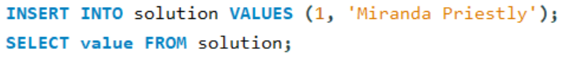

**Output** Congrats, you found the brains behind the murder! Everyone in SQL City hails you as the greatest SQL detective of all time. Time to break out the champagne!